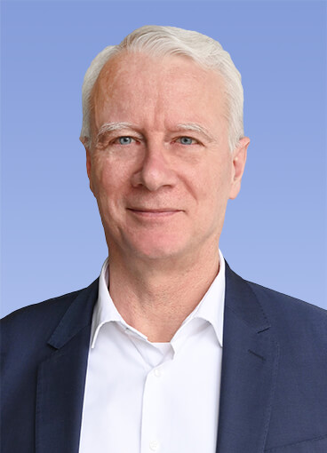 | Francois Stouvenot  CEO EMEA & North America  Yanfeng Automotive Interiors
In his function as CEO EMEA and NA at Yanfeng Automotive Interiors (YFAI), Francois Stouvenot is located in our Automotive Business Center in Bratislava, Slovakia.
In addition to his role as Executive Vice President Global Commercial at Yanfeng he took over the responsibility as General Manager EMEA, YFAI, in December 2021.
Francois joined Yanfeng as Executive Vice President Commercial in 2019 being responsible for the global Customer Business Units. He provided strong strategic insights and played a major role in Yanfeng's new businesses. Besides that, he positioned One Yanfeng as a key global strategic automotive supplier.
With over 35 years of strong expertise in engineering, sales, business, and international leadership in several senior management positions both in the automotive tier 1 and plastics material supplier areas, Francois has a diverse background and extensive global experience.
Before joining Yanfeng he held the position of Chief Commercial Officer and Deputy CEO at Dura Automotive Systems in Detroit, USA, since 2007, where he began his career as General Manager Europe in Paris in 2003. Prior to this, he held increasingly responsible management positions within The Dow Chemical Company for 16 years, mainly in the Engineering department and the Automotive division. His working life started in 1987 as Engineering Resins R&D Manager and Product Manager in Lyon, France, followed by positions as Business Director Engineering Resins & Compounds Europe and General Manager of the Automotive Division EMEA in Zurich, Switzerland.
Francois studied Chemistry and has graduated the ITECH school based in Lyon, France. Thereafter he completed an Executive MBA at the CPA/HEC school in Paris.
He was born in Lorraine, France, in 1962, is married and has three children.

